COUNCIL ASSESSMENT REPORT
WESTERN REGIONAL PLANNING PANEL

PANEL REFERENCE & DA NUMBER | PPSWES-143
PROPOSAL | Public Administration Building and consolidation/boundary adjustment
ADDRESS | Lots 21 & 22 DP 565246, Lot 100 DP 1098632, & Lot 3 DP 1128529 Res 24309, Lot 4 DP 1128529,  37-39 Carrington Avenue & 130-142 Brisbane Street Dubbo
APPLICANT | Property NSW
OWNER | Property NSW
DA LODGEMENT DATE | 25 July 2022
APPLICATION TYPE | Crown Development Application
REGIONALLY SIGNIFICANT CRITERIA | Clause 4, Schedule 6 of State Environmental Planning Policy (Planning Systems) 2021 : Crown Development Over $5 million
CIV | $35,787,134.00 (excluding GST)
CLAUSE 4.6 REQUESTS | N/A
KEY SEPP/LEP | - SEPP (Planning Systems) 2021 – Chapter 2 State and Regional Development  - SEPP (Resilience and Hazards) 2021 – Chapter 4 Remediation of Land  - SEPP (Transport and Infrastructure) – Chapter 2 Infrastructure  - Dubbo Regional LEP 2022
TOTAL & UNIQUE SUBMISSIONS KEY ISSUES IN SUBMISSIONS | Four (4) submissions received.  - Impacts on neighbouring radio tower  - Boundary fence replacement and security issues  - Construction noise impacts  - Off-street car parking
DOCUMENTS SUBMITTED FOR CONSIDERATION | - Statement of Environmental Effects (7/7/2022)  - Architectural Drawings (19/10/2022)  - Architectural Design Report (25/7/2022)  - Civil Engineering Plans (7/7/2022)  - Contamination Report (7/7/2022)  - Quantity Surveyors Report (7/7/2022  - Heritage Impact Statement (7/7/2022  - Landscape Plans (7/7/2022)  - Subdivision Plans (7/7/2022)  - Traffic Report (25/7/2022)  - Operational Waste Management Plan (7/7/2022)
SPECIAL INFRASTRUCTURE CONTRIBUTIONS (S7.24) | N/A
RECOMMENDATION | Approval
DRAFT CONDITIONS TO APPLICANT | Yes. Crown concurrence provided 13 March 2023
SCHEDULED MEETING DATE | 18 April 2023
PLAN VERSION | Select Date Version No
PREPARED BY | Shaun Reynolds – Statutory Planning Services Team Leader
DATE OF REPORT | 23 March 2023

EXECUTIVE SUMMARY

The development application (D22-356) seeks consent for a new public administration building and associated civil and landscaping works. The proposed development will include five (5) working levels plus an additional two (2) basement levels for underground car parking. There will also be provision for a yarning circle and surrounding landscaping.

The development will also include a subdivision comprising the consolidation and realignment of property boundaries to suit the overall development footprint and to enable the management of servicing, access and car parking arrangements.

The subject site is known as Lots 21 & 22 DP 565246, Lot 100 DP 1098632, & Lot 3 DP 1128529 Res 24309, Lot 4 DP 1128529, No’s. 37-39 Carrington Avenue & 130-142 Brisbane Street, Dubbo. The allotments are located on the western side of Carrington Avenue and eastern side of Brisbane Street. The allotments combined have an area of 5,010m² with a frontage to Carrington Avenue of 41 metres and Brisbane Street of 61 metres. Vehicular access to the site can be obtained via either Carrington Avenue or Brisbane Street, both bitumen sealed public roads with ‘upright’ kerb and guttering.

The site presently comprises a three (3) storey public administration building. This Application is for construction works only. The demolition of the existing building and structures on 37-39 Carrington Avenue was considered under a previous Development Consent – D2022-205 approved 25 July 2022.

The subject property is located on the edge of the Dubbo Central Business District, with surrounding land uses predominantly being office based in nature.

The site is located in the B3 – Commercial Core zone pursuant to Clause 2.2 of the Dubbo Regional Local Environmental Plan 2022 (‘LEP 2012’). Public Administrative Buildings are permissible in the B3 zone.

There were no concurrence requirements from agencies for the proposal and the application is not Integrated Development pursuant to Section 4.46 of the Environmental Planning and Assessment Act 1979 (‘EP&A Act’). A referral to Essential Energy pursuant to State Environmental Planning Policy (Transport and Infrastructure) 2021 (‘Transport and Infrastructure SEPP’) were sent and raised no objections. Their conditions and requirements will be included as a notation on the consent.

The Application is considered Crown Development. The Applicant and owner of the site is Property NSW. Property NSW is a State Government agency and its staff are employed in the service of the Crown. The proposed development is to be undertaken by the Crown which as a consequence, invokes the provisions under Section 4.33(1) of the Environmental Planning & Assessment Act 1979 that prevent Council from imposing conditions on the Development Consent except with the Applicant’s or Minister’s approval. The Applicant has provided concurrence to the draft conditions of consent. This was provided to Council on 13 March 2023.

The application was placed on public exhibition from 29 July 2022 to 17 August 2022, with four (4) submissions being received. These submissions which raised issues relating to impacts on neighbouring radio tower, boundary fence replacement and security issues, construction noise impacts, and off-street car parking. These issues are considered further in this report.

The application is referred to the Western Region Planning Panel (‘the Panel’) as the development is ‘regionally significant development’, pursuant to Clause 4 of Schedule 6 of State Environmental Planning Policy (Planning Systems) 2021 as the proposal is development for crown development with a CIV over $5 million.

A briefing was held with the Panel on 19 September 2022 where key issues were discussed, including off-street car parking provisions, streetscape impact, parking space dimensions, truck and delivery vehicle movements, waste generation, and the contents of the submissions received.

Following a detailed assessment of the proposal, pursuant to Section 4.16(1)(b) of the EP&A Act, D22-356 is recommended for approval subject to the conditions of consent contained at Attachment A of this report.

- THE SITE AND LOCALITY

  - The Site

Locality
The allotments are located on the western side of Carrington Avenue and eastern side of Brisbane Street. The allotments combined have an area of 5,010m² with a frontage to Carrington Avenue of 41 metres and Brisbane Street of 61 metres. For a locality map of the site see Figure 1.

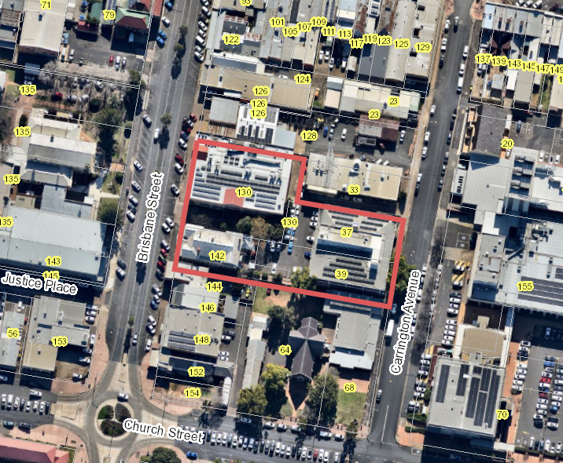
Figure 1: Aerial image of subject property and locality

Slope
The natural slope of the land is slightly down to the west.

Vegetation
The site has been previously cleared of native vegetation. Introduced landscaping will be removed to accommodate the new development, with new landscaping to be provided.

Access
Vehicular access to the site can be obtained via either Carrington Avenue or Brisbane Street, both bitumen sealed public roads with ‘upright’ kerb and guttering.

Drainage
Stormwater from the site drains into the street kerb on Carrington Avenue and Brisbane Street.

Services
The site is connected to all utility services (water, sewer, stormwater and electricity).

  - The Locality

Adjoining uses

North: Commercial (business premises (radio 2DU) and vehicle repair station)
South: retail premises (café) and place of worship
East: Public administration building (Dubbo Regional Council) and Dubbo Regional Theatre and Convention Centre (rear entrance)
West: Dubbo Court House and police station

- THE PROPOSAL AND BACKGROUND

  - The Proposal

The proposed development is for the purpose of a new public administration building and associated civil and landscaping works. The proposed development will include five (5) working levels plus an additional two (2) basement levels for underground car parking. There will also be provision for a yarning circle and surrounding landscaping. According to the Statement of Environmental Effects (SEE) each level will comprise:

- Level 5 – Plant;
- Level 4 – Collaborative area, kitchenette, four (4) quiet working rooms, four (4) meeting rooms, office working space, amenities, work room (Biodiversity Conservation Division) and plant;
- Level 3 – Collaborative area, kitchenette, four (4) quiet working rooms, four (4) meeting rooms, office working space, amenities, evidence room (Environmental Protection Authority) and plant;
- Level 2 – Collaborative area, kitchenette, eight (8) quiet working rooms, six (6) meeting rooms, office working space, amenities and plant;
- Level 1 – Six (6) meeting/training rooms, two (2) quiet rooms, kitchen and terrace area, office working space, amenities and plant;
- Ground Level – Public lobby area, amenities, two (2) meeting rooms, three (3) interview rooms, building manager’s office, loading dock, two (2) car parking spaces, staff amenities, bicycle parking, storage, waste storage and collection area and car park entrance. External to the building is a proposed pocket park along with pedestrian access pathways and extensive landscaped areas;
- Basement 1 – 34 car parking spaces (plus two (2) motorcycle spaces), storage and plant; and
- Basement 2 – 36 car parking spaces (plus two (2) motorcycle spaces), storage and plant.

It is understood the purpose of the building is to house and centralise a number of State Government Departments. An architectural image of the development is provided in Figure 2.

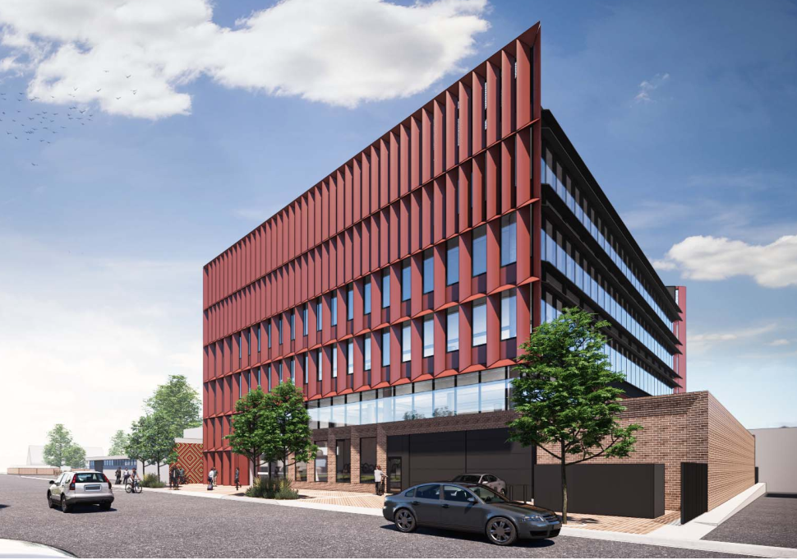
Figure 2: Architectural image 37-39 Carrington Avenue
The development will also include a subdivision comprising the consolidation and realignment of property boundaries to suit the overall development footprint and to enable the management of servicing, access and car parking arrangements. Five (5) existing allotments will be rationalised into three (3) allotments as follows:

- Proposed Lot 103 of approximately 1,941m² fronting Brisbane Street and occupied by the existing two (2) story government office building;
- Proposed Lot 104 of approximately 2,338m² fronting Carrington Avenue and on which the new building is to be developed; and
- Proposed Lot 105 of approximately 732.8m² fronting Brisbane Street and occupied by the existing Lands Department building.

The proposed lot layout will be provided in Figure 3.

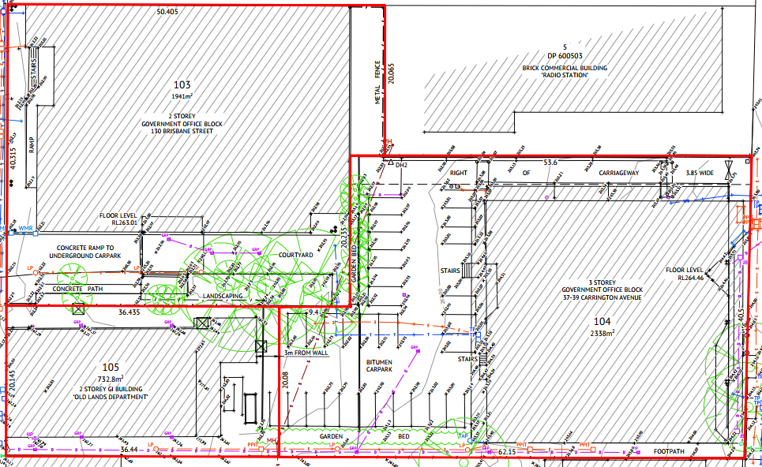
Figure 3: Proposed lot layout – Lots 103-105

Significant excavation will be required to facilitate the construction of the new basement levels. In terms of signage, the Application identifies that these will be submitted under separate cover.

This Application is for construction works only. The demolition of the existing building and structures on 37-39 Carrington Avenue was considered under a previous Development Consent – D2022-205 approved 25 July 2022.

  - Background

Various informal discussion were held between the proponent, their consultant and relevant Council staff to discuss the development proposal and the key issue.

Table 2: Chronology of the DA
Date | Event
7 July 2022 | DA lodged (Application fees paid 25 July 2022)
25 July 2022 | Exhibition of the application
29 July 2022 | DA referred to external agencies
19 September 2022 | Panel briefing
29 September 2022 | Request for Information from Council to applicant
19 October 2022 | Further Information received
6 December 2022 | Draft consent provided to Crown
22 December 2022 | Crown response received objecting to limited conditions
3 March 2023 | Amended draft consent provided to Crown
13 March 2023 | Crown provided acceptance to draft consent

  - Site History

The demolition of the building and surrounding infrastructure of No’s 37-39 Carrington Avenue was approved on 25 July 2022 (Development Consent D2022-205). That Application was deemed Crown Development and was subject to the requirements of Crown Development under the Environmental Planning and Assessment Act 1979, including ‘concurrence’ to the conditions of consent prior to determination.

The existing State Government building on No’s 37-39 Carrington Avenue was approved under Development Consent D1973-90 for the purpose of housing state government agencies. Since its occupation there have been a number of approvals for internal alterations to this building.

The building at No.130 Brisbane Street was approved 8 March 1988 (Development Consent D1988-160). Since its occupation there have been a number of approvals for internal alterations to the building.

According to the NSW State Heritage Inventory, the building at No.142 Brisbane Street was completed in 1897 as the Lands Office. The veranda was added in 1899 and restoration works were undertaken in 1976.

There are no issues from previous development approvals, which require further consideration.

- STATUTORY CONSIDERATIONS

When determining a development application, the consent authority must take into consideration the matters outlined in Section 4.15(1) of the Environmental Planning and Assessment Act 1979 (‘EP&A Act’). These matters as are of relevance to the development application include the following:

- the provisions of any environmental planning instrument, proposed instrument, development control plan, planning agreement and the regulations
(i) any environmental planning instrument, and
(ii) any proposed instrument that is or has been the subject of public consultation under this Act and that has been notified to the consent authority (unless the Planning Secretary has notified the consent authority that the making of the proposed instrument has been deferred indefinitely or has not been approved), and
(iii) any development control plan, and
(iiia) any planning agreement that has been entered into under section 7.4, or any draft planning agreement that a developer has offered to enter into under section 7.4, and
(iv) the regulations (to the extent that they prescribe matters for the purposes of this paragraph),
that apply to the land to which the development application relates,
- the likely impacts of that development, including environmental impacts on both the natural and built environments, and social and economic impacts in the locality,
- the suitability of the site for the development,
- any submissions made in accordance with this Act or the regulations,
- the public interest.

These matters are further considered below.

It is noted that the proposal is not considered to be:

- Integrated Development (s4.46)
- Designated Development (s4.10)
- Requiring concurrence/referral (s4.13)

The Application is considered Crown Development. The Applicant and owner of the site is Property NSW. Property NSW is a State Government agency and its staff are employed in the service of the Crown. The proposed development is to be undertaken by the Crown which as a consequence, invokes the provisions under Section 4.33(1) of the Environmental Planning & Assessment Act 1979 that prevent Council from imposing conditions on the Development Consent except with the Applicant’s or Minister’s approval. The Applicant has provided concurrence to the draft conditions of consent. This was provide to Council on 13 March 2023.

  - Environmental Planning Instruments, proposed instrument, development control plan, planning agreement and the regulations

The relevant environmental planning instruments, proposed instruments, development control plans, planning agreements and the matters for consideration under the Regulation are considered below.

- Section 4.15(1)(a)(i) - Provisions of Environmental Planning Instruments

The following Environmental Planning Instruments are relevant to this application:

- State Environmental Planning Policy (Planning Systems) 2021;
- State Environmental Planning Policy (Resilience and Hazards) 2021;
- State Environmental Planning Policy (Resources and Energy) 2021;
- State Environmental Planning Policy (Transport and Infrastructure) 2021; and
- Dubbo Regional Local Environmental Plan 2022.

A summary of the key matters for consideration arising from these State Environmental Planning Policies are outlined in Table 3 and considered in more detail below.

Table 3: Summary of Applicable Environmental Planning Instruments

EPI | Matters for Consideration  (Brief summary) | Comply (Y/N)
State Environmental Planning Policy (Planning Systems) 2021 | Chapter 2: State and Regional Development  - Section 2.19(1) declares the proposal regionally significant development pursuant to Clause 4 of Schedule 6 as it comprises Crown Development with a CIV over $5 million. | Y
SEPP (Resilience & Hazards) | Chapter 4: Remediation of Land  - Section 4.6 - Contamination and remediation has been considered, primarily with respect of the existing building on the site to be demolished. The proposal is satisfactory subject to conditions. | Y
State Environmental Planning Policy (Transport and Infrastructure) 2021 | Chapter 2: Infrastructure  - Section 2.48(2) (Determination of development applications—other development) – electricity transmission - the proposal is satisfactory subject to recommended conditions/requirements that will be included as a notation on the consent.  - Section 2.88(1) outlines that development for the purpose of a public administrative building may be carried out by or on behalf of a public authority with consent in a prescribed zone. | Y
LEP | - Clause 2.3 – Permissibility and zone objectives  - Clause 2.6 – Subdivision – Consent requirements  - Clause 5.10 – Heritage Conservation  - Clause 5.14 – Siding Spring Observatory – Maintaining Dark Sky  - Clause 5.21 – Flood Planning  - Clause 7.2 – Earthworks  - Clause 7.5 – Groundwater Vulnerability  - Clause 7.7 – Airspace Operations | Y

Consideration of the relevant SEPPs is outlined below

State Environmental Planning Policy (Planning Systems) 2021 (‘Planning Systems SEPP’)

Chapter 2: State and Regional Development

Clause 2.19 and Schedule 6 identifies development that is considered regionally significant. The development proposal meets the criteria as it has a capital investment value if over $5 million and is Crown Development (clause 4). Consequently, the determining authority is the Western Region Planning Panel.

State Environmental Planning Policy (Resilience and Hazards) 2021

Chapter 4: Remediation of Land

A review of the history of use of this land does not identify any potentially contaminating activities that may have occurred. Further, the new use is similar to the existing use ensuring a more sensitive land use will not be undertaken.

Given the age of the existing building it may have included potentially contaminating products in its construction (e.g. asbestos, lead paint etc). The development consent for the buildings demolition (D2022-205) included conditions regarding the safe removal and disposal of hazardous materials. Through such works it is considered that post demolition the site will be made safe for future use. No further considerations.

State Environmental Planning Policy (Transport and Infrastructure) 2021

Chapter 2- Infrastructure

Development adjacent to electricity transmission

The application was referred to Essential Energy in accordance with Clause 2.48 for which they responded in correspondence dated 8 September 2022, raising no objection to the proposed development. The requirements specified by Essential Energy will be included on the development consent as notations, as Council is unable to enforce such requirements.

Public administration buildings and buildings of the crown

Pursuant to Clause 2.88(1) development for the purpose of public administration buildings may be carried out by or on behalf of a public authority with consent on land in a prescribed zone. In this regard, it is noted the Applicant is Property NSW (a public authority), and the land is zoned B3 which is a prescribed zone (see clause 2.85).

As per clause 2.89, the proposal does not constitute any works that can be undertaken without consent (example demolition, alterations and additions, replacement of building not exceeding 12 metres in height).

Note: While a number of other SEPPs apply to the land, none are specifically applicable to this development.

Dubbo Regional Local Environmental Plan 2022

The relevant Local Environmental Plan applying to the site is the Dubbo Regional Local Environmental Plan 2022 (‘the LEP’). The proposed development is not contrary to the relevant aims of the Plan.

Zoning and Permissibility (Part 2)

The site is located within the B3 Zone pursuant to Clause 2.2 of the LEP (see Figure 4 below).

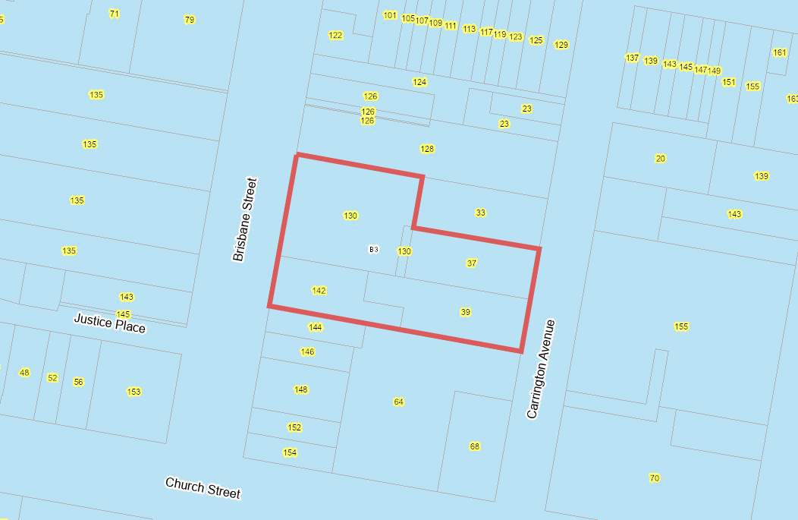
Figure 4: Dubbo LEP 2022 zoning map

The proposed development is defined under the Dubbo Regional Local Environmental Plan 2022 as a public administration building, which is defined as:

“a building used as offices or for administrative or other like purposes by the Crown, a statutory body, a council or an organisation established for public purposes...”

The proposed development for a public administration building is permitted with development consent in the B3 zone under State Environmental Planning Policy (Transport and Infrastructure) 2021.

The proposed development complies with the relevant objectives of the B3 zone, in particular

  - To provide a wide range of retail, business, office, entertainment, community and other suitable land uses that serve the needs of the local and wider community;
  - To encourage appropriate employment opportunities in accessible locations;
  - To strengthen the viability of existing centres through increased economic activity and employment; and
  - To ensure the Dubbo central business district continues to be the commercial and retail centre of the region.

The remaining zone objectives are not applicable in this instance.

General Controls and Development Standards (Part 2, 4, 5 and 6)

The LEP also contains controls relating to development standards, miscellaneous provisions and local provisions. Those relevant to tis Development Application are detailed below.

Clause 1.9A Suspension of covenants, agreements and instruments

A review of the Deposited Plans and corresponding Section 88B Instruments indicates a Right of Carriageway 3.85 metres wide that provides legal access from Lot 100 to Carrington Avenue that burdens Lots 21 and 22 (see Figure 5).

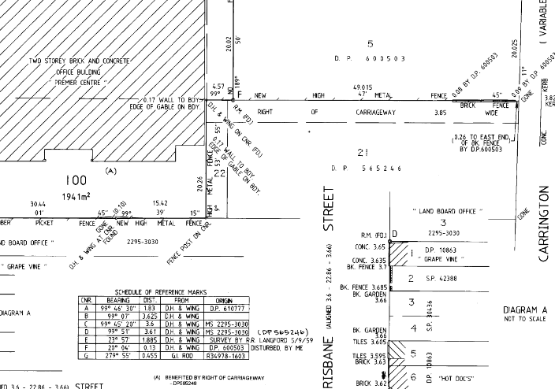
Figure 5: Deposited Plan 1098632 showing ROW across Lots 21 and 22

The proposed subdivision plan (Figure 3) identifies the ROW being preserved. It will be located along the northern boundary of proposed Lot 104 to benefit Lot 103.

The Application also identifies that the boundary adjustment/consolidation will include the creation of the following easements:

- easement over existing sewer;
- easement over proposed stormwater infrastructure, including overflow paths; and
- easement to enable pedestrians right of access throughout the site.

A condition of consent will require the ROW and easements to be provided on the relevant plans and documentation with the Subdivision Certificate.

Clause 2.6 Subdivision – consent requirements

As identified, the proposal includes the boundary adjustment/consolidation of five (5) allotments into three (3) allotments that promote a more orderly and efficient lot layout and ensure buildings do not straddle allotment boundaries.

There are no Minimum Lot Size provisions in the B3 zone, therefore compliance is based on merit. In this regard, it is considered the lot layout and lot sizes are suitable to accommodate development, and that ensures compliance with the Building Code of Australia with respect to buildings and their proximity to fire source features (allotment boundaries).

Clause 5.10 Heritage Conservation

Lot 3 contains a locally listed heritage item, being the Dubbo Lands Office (Item No.I51). In addition, the following locally listed heritage items are located in proximity to the site:

- Dubbo Courthouse – 137 Brisbane Street (Item No.I50);
- Dwelling house and retail premises – 142 Brisbane Street (Item No.I52); and
- ‘The Drop Inn’ and Wesley Centre Uniting – 64 Church Street (Item No.I84).

Council’s Heritage Adviser in reviewing the development proposal provided the following comments:

“The proposed new building has echoes of the existing one in the varying large scale sun control on its elevations. It will sit well in the streetscape. It is reasonably distant from the nearby items and will not visually dominate or overwhelm them.

The only concern is the view of the building as a backdrop to heritage items now silhouetted against the sky, and this is only an issue when facing north from the grounds with the church at the left of the field of view. However the main distraction here is the view of the church hall in the foreground. The presence of the higher building in the background will have an adverse impact, but only a minor one.

There is no objection to the proposal from a heritage viewpoint.”

The Heritage Advisor also suggested conditions regarding a photographic archival record be provided of the existing building prior to it demolition. However, noting consent for its demolition has already been issued, and the building is neither an item itself nor a contributory building to the CBD heritage precinct (see Chapter 3.4 of Dubbo DCP 2013), this is not considered necessary.

Clause 5.14 Siding Spring Observatory – maintaining dark sky

The proposed development has been assessed as unlikely to adversely affect observing conditions at the Siding Spring Observatory, having regard to subclauses:

- 2(a) - the amount of light to be emitted;
- 2(b) - the cumulative impact of the light emissions with regard to the critical level;
- 2(c) - outside light fittings (shielded light fittings);
- Metres for all levels above this2(d) - measures taken to minimise dust associated with the development; and
- 2(e) - the Dark Sky Planning Guidelines published by the Secretary under clause 61 of the EP&A Regulation 2022.

Additionally, as per subclause (7) the proposed development is not considered likely to result in the emission of light of 1,000,000 lumens or more. An appropriate condition will be included on the consent that any external lighting associated with the development be shielded and pointed downwards to not emit light into the night sky or adjoining property.

Clause 5.21 Flood planning

The site is partially affected by the Flood Planning Area (1% Annual Exceedance Probability flood level + 500mm) on relevant LEP mapping. Under Council’s Flood Prone Land Policy the 1% AEP flood level stands at 262.5m AHD (cross section 14 – Church Street), with the Flood Planning Level being 263m AHD. The existing ground level for the development site ranges from 263m AHD (western boundary) to 264m AHD (eastern boundary). Accordingly, the building footprint and finished floor level of the ground floor and above will be above the Flood Planning Level. The entrance to the basement car park will also be above the 1% AEP level, ensuring inundation would not occur.

It is noted that under the draft Cardno-Willing Flood Study the site is identified as being affected by the Flood Planning Area at 263.1mAHD, being 0.6 metres above the existing 1% AEP flood level. As the Cardno-Willing flood study is a draft document with no legal standing or guarantee of future adoption as Council Policy, only a notation to this effect is recommended on the consent.

Clause 7.2 Earthworks

The proposed development will require earthworks to be undertaken upon the site. Erosion and sediment control measures (as part of a Soil and Water Management Plan) are required before any earthworks commence in which a condition to this effect will placed on the consent.

Clause 7.5 Groundwater vulnerability

The land is included on the Natural Resource – Groundwater Vulnerability Map. The proposed development, despite including below ground excavation is not likely to cause groundwater contamination nor will it likely have an effect on any groundwater dependent ecosystems. Groundwater monitoring bores in the area have groundwater levels deeper than the 258m AHD identified on basement plans. The development is also considered not likely to have a cumulative impact on groundwater.

Clause 7.7 Airspace operations

The subject site is located within the Obstacle Limitation Surface Map at height 330mAHD. The site for the proposed development has a maximum surface level of 264mAHD. Plans demonstrate the development having a maximum height of 288.4mAHD, 41.6 metres below the surface map.

- Section 4.15 (1)(a)(ii) - Provisions of any Proposed Instruments

No draft environmental planning instruments apply to the land to which the Development Application relates.

- Section 4.15(1)(a)(iii) - Provisions of any Development Control Plan

The following Development Control Plan is relevant to this application:

- Dubbo Development Control Plan 2013 (‘the DCP’)

An assessment is made of the relevant chapters and sections of this DCP. Those chapters or sections not discussed here were considered not specifically applicable to this application or are discussed elsewhere in this report.

Chapter 2.2 Commercial Development and Subdivision

Section 2.2.5 – Development Controls

Element 1 - Setbacks

The development will provide a consistent 3.62 metre front (eastern) setback across all levels. The DCP for the B3 zone stipulates that buildings for the first three (3) above ground levels (ground, first and second floor) may have a zero setback, then be setback 3 metres for the third floor level and a further 3 metres for each additional 3 storeys. Noting the building is five (5) storeys compliance is achieved.

The northern setback will be 0.59 metres for the first storey, then approximately 5.6 metres for all storeys above this. The southern side setback will be a consistent 2.2 metres. For side boundaries the DCP requires a zero setback at ground floor level and 3 metres for all storeys above this. Compliance is therefore not achieved for the southern setback. Noting this, the Applicant states the following:

“The development character within Dubbo CBD invites higher densities and building heights. The proposed development provides a generous main entrance into the foyer of the new building and creates activation of the streetscape. The shadowing generated from the new building is not anticipated to result in significant impacts on adjoining development.”

Shadow diagrams have been provided and will be discussed elsewhere in this report to demonstrate minimal impacts as discussed above. Overall, noting the scale and design of the building, it is considered the setbacks suitable.

There are no numerical controls for rear setbacks, only a merit assessment that the setback is of a sufficient size to ensure development can be adequately serviced. Through the design access for vehicles is not available to the rear of the site, however all servicing will be undertaken from the front of the site. Pedestrian access is still able to be achieved. The generous rear setback will incorporate landscaping and the yarning circle and ensures a suitable setback to the heritage item at the rear.

Element 2 – Building Design

It is considered the proposed development makes a positive contribution to the Carrington Avenue frontage. Plans demonstrate masonry, metal and glass finishes with car parking obscured. It is considered the design conforms to the acceptable solutions of the DCP through providing a visually interesting facade, architectural emphasis and colour articulation. Material will be non-reflective.

There are no numerical height controls for the B3 zone. The building height is considered suitable for the area.

The design of the ground floor level, with large open windows facing directly to the street, ensures passive surveillance to the public domain.

Element 3 – Landscaping

Landscape Plans have been provided which demonstrate extensive landscaping, particularly at the rear of the site. Existing established trees will be removed and replaced with mass plantings and new trees. This will provide a landscaped corridor through to Brisbane Street, as well as surrounding the yarning circle which will act as a passive break out area for staff.
In addition two (2) existing street trees will be removed at the front of the site and replaced by new trees. Council’s Manager Recreation and Open Space in his assessment has valued the removal of these trees at $16,138.00 (northern tree), and $8,233.00 (southern tree). An appropriate condition will be included on the consent that the Applicant make the necessary contribution prior to the removal of these trees, noting such works will be required to be undertaken by Council.

From review of the plans it is noted four (4) replacement trees are proposed, however it is unclear the species proposed. Due to the limited planting and growth envelopes, and to avoid services and future damage, Council’s Manager Recreation and Open Space recommends these trees be limited to Tristaniopsis Laurina “Luscious” or similar sized trees. Suitably sized root vaults will also be required to be installed. It was also advised the garden beds shown on plans are not required. Again, noting such works will be required to be undertaken by Council, an appropriate condition will be included on the consent that such works be undertaken in consultation with Council.

Appropriate conditions will be included on the consent for the establishment of landscaping in accordance with approved plans prior to occupation of the building, as well as the appropriate approvals from Council prior to planting being undertaken in the road reserve.

Element 4 – Vehicular access and parking

Plans demonstrate vehicular access to the site will be obtained via a combined entry/exit driveway off Carrington Avenue. This will serve the ground floor loading dock, as well as the two (2) basement levels for parking.

Swept paths have been provided which demonstrate vehicles can effectively manoeuvre within the basement areas including into and out of parking spaces and the loading dock.

Plans originally submitted demonstrated a loading area at the front of the building adjacent to the footpath. Council raised concerns with this arrangement from an amenity and functionality perspective (including pedestrian safety). Following a request for further information, the Applicant advised this component will be removed and replaced with additional landscaping. It was advised the purpose of this loading area was intended primarily for garbage removal, which will now be undertaken kerbside.

A review of required parking will be undertaken under Dubbo DCP 2013, Chapter 3.5.

Element 5 – Fencing and Security

Access to the car parking areas will be restricted via roller shutters. These are setback 6 metres from the property boundary to ensure no conflict with road/pedestrian traffic, while gates are being opened or closed.

As discussed, the design of the building ensures passive surveillance of the public domain to minimise risk of anti-social behaviour. Other security measures of note include restricted access to the basement carpark, and outdoor landscaped areas including the yarning circle being benefitted by passive surveillance as well as lighting for afterhours safety.

Element 6 – Design for access and mobility

An assessment will be undertaken under Dubbo DCP 2013, Chapter 3.1 Access and Mobility.

Element 7 – Waste Management

An appropriate condition will be included on the consent for the disposal of construction waste (including soils) at an appropriately licenced waste facility.

The Applicant has submitted an Operational Waste Management Plan. Plans demonstrate a waste storage area on the ground floor adjacent to the loading dock. The Plan identifies that a private waste contractor will be engaged to collect waste as per an agreed schedule.

Following clarification by the Applicant it was identified that waste bins will be collected kerbside, rather than entering the site.

The development will not be a generator of liquid trade waste.

Element 8 – Soil, water quality and noise management

Upon completion of the development the property will be mainly hardstand or landscaped, ensuring soil erosion is unlikely. During construction however, soils will be exposed meaning runoff may occur during a rain event. The Construction Environmental Management Plan to be submitted prior to works commencing will detail erosion and sediment control measures to ensure sediments are not dispersed from the site into the local stormwater system.

It is anticipated that there will be no adverse water or noise impacts as a consequence of this development. It is considered that the development will not generate any noise above that of neighbouring commercial land uses. Standard conditions with regard to excessive noise will be included on the consent, including restricting construction work hours.

Element 9 – Signage and advertising

The Application advises that no signage is proposed. An appropriate condition will be included on the consent that separate approval will be required for any business identification signage.

Element 10 – Services

Given the location of the site in the Central Business District there is ready access to all reticulated utility services. Council’s Infrastructure Strategy Branch has reviewed the development proposal and determined utility servicing in the locality should be adequate to serve this development, although a notation was still recommended that the Applicant liaise with Council’s Water and Sewerage Branch to confirm. An appropriate condition will be included on the consent that a larger water service connection be provided if needed.

Section 2.2.6 – Subdivision Controls

Element 1 – Lot size and dimensions (consolidation)

The objective of this element is to encourage consolidation of land in the B3 zone to provide larger single development sites. Where consolidation occurs, development shall be given ‘parking bonuses’. Where there are two (2) or more allotments with a combined area of greater than 2,000m², and an average width of 30 metres, they shall receive a 20% car parking reduction. The subject site comprises Lot 21 DP 565246 (1,010m²) and Lot 4 DP 1205286 (1,150m²), having a combined area 2160m² with an average width of approximately 40 metres. As such, the redevelopment of the site is entitled to a 20% car parking reduction.

Noting the concession above, a further car parking analysis will be undertaken under Dubbo DCP 2013, Chapter 3.5.
Chapter 3.1 – Access and Mobility

Section 3.1.2 Legislative Requirements

The Application will be assessed against the Premises Standards in the Access Code under the Disability Discrimination Act 1992. The plans themselves are not sufficient to conduct a detailed assessment as to the building’s compliance, however, a basic assessment can still be made to determine any obvious non-conformities that may be required to be amended prior to development approval.

Section 3.1.8 Development Controls

Design Element 1 – Access Routes and Entrances

Plans demonstrate pedestrian access (staff and public) will be via the main entry doors into the foyer, with lifts providing access to other floors.

Design Element 2 – Access to Internal Facilities

A brief overview of the proposed floor plans demonstrates that disabled access to all internal components of the commercial aspect of the development will be able to be achieved. This includes sanitary facilities. No ramps are proposed.

One (1) accessible toilet is proposed on each level (excluding basement levels). Although it is not possible to make a detailed assessment of its compliance, the dimensions of this room complies with the Premises Standards which is required to be a minimum 2,300mm x 1,900mm. Specific details of the sanitary facility, door widths, rail heights etc., will be required to be certified by the development’s certifier.

Design Element 3 – Car Parking and Setdown Areas

Plans show the provision of two (2) disabled car parking spaces on each of the basement levels. The dimensions of these spaces appear to comply with the Premises Standards (i.e. 2.4 metre wide parking space and 2.4 metre wide ‘shared zone’). Plans also show a continuous path of travel via concrete sealed driveways and lifts to other components of the development.

The above spaces will be for use by staff only. The Applicant proposes to also dedicate a disabled parking space on Carrington Avenue for use by the general public. A kerb ramp will be provided adjacent to this space for accessibility to the footpath and into the building.

Chapter 3.4 – Heritage Conservation

The property is located within the Central Business District Heritage Precinct. As discussed previously in this report, it is considered the development will not have an adverse impact on the heritage precinct, or any heritage items in the vicinity of the site.

Chapter 3.5 – Parking

The proposal would be considered an office premises that requires one (1) space per 40m² Net Lettable Area (NLA). Note, NLA is defined as: the overall useable area of the building that excludes aspects such as amenities, stairways, lift wells, public foyers and plant rooms. From review of plans, a breakdown of parking requirements based on each floor’s NLA is shown below:

Level | NLA (m²) | Parking requirement
Ground floor | 245.5 | 6.14
First floor | 553.3 | 13.8
Second floor | 769.1 | 19.2
Third floor | 774 | 19.4
Fourth floor | 779.4 | 19.5
Fifth floor | N/A (plant only) | Nil
 | Total | 78.04 (say 78)

Plans show the provision of 72 spaces, a deficit of six (6).

As discussed under Section 2.26 of the DCP, noting the lot consolidation, the site is eligible for a 20% parking reduction, the parking requirement would therefore be 62.4 spaces. Compliance is therefore achieved.

In addition to the parking spaces, plans demonstrate provision of four (4) motor cycle parking spaces, and a bicycle storage facility. The DCP does not require provision of such parking facilities for this type of development.

Flood-Prone Land Policy

As discussed previously in this report, the site is partially affected by the Flood Planning Area (1% Annual Exceedance Probability flood level + 500mm) on relevant LEP mapping. Under Council’s Flood Prone Land Policy the 1% AEP flood level stands at 262.5m AHD (cross section 14 – Church Street), with the Flood Planning Level being 263m AHD. The existing ground level for the development site ranges from 263m AHD (western boundary) to 264m AHD (eastern boundary).

Accordingly, the building footprint and finished floor level of the ground floor and above, as well as the basement entrance, will be at or above the Flood Planning Level.

Section 4.6 – Requirements for Emergency Service Infrastructure

The remainder of the site is mapped as being within the Probable Maximum Flood Area. However, as the development is not for essential service infrastructure there are no further considerations under this Section.

The following contributions plans are relevant pursuant to Section 7.18 of the EP&A Act and have been considered in the recommended conditions (notwithstanding Contributions plans are not DCPs they are required to be considered):

CONTRIBUTIONS Section 64 & Section 7.11

Contributions will be calculated as follows, noting credits from the existing building located on the land.

Sewer Headworks Contribution

For commercial developments sewer contributions are levied based on 0.125 ETs per 1,000m² floor space, plus 0.5 ETs per toilet.

The existing building has a Gross Floor Area of 2,532m², and contains 18 toilets. The credit is therefore 9.3165 (say 9.3) ET.

In terms of the proposed development, the GFA of 4,813.6m² and contains 65 toilets. The ET is therefore 33.1017 (say 33.1).

The contribution is therefore:

Contribution = rate x (ET – credit)
= $6,235.30 x (33.1 – 9.3)
= $6,235.30 x 23.8
= $148,400.14

Water Headworks Contribution

For commercial developments, contributions are levied based on the number of staff and plumbing fixtures to determine water usage.

Section 3.5.1 of the Plan identifies alternative sources to assist in determining contributions if available. In this instance the Applicant has identified an alternative methodology of calculating contributions.

While still being consistent with Policy methodology, the alternative methodology more accurately reflects the expected usage of fixtures rather than a more ‘domestic’ permanently occupied building as the Policy recommends. The methodology more reasonable assumes that each person employed within the building would utilise just one (1) toilet and hand basin each day (six (6) visits per day), as opposed to using all facilities as the Policy assumes.

Noting the Premise methodology the net increase in water usage is determined as 16,599 litres (i.e. proposed 46,975.5L – existing 30,376.5L), which equates to 3.3198 (say 3.3) ETs. Contribution is therefore:

Contribution = rate x 3.3ET
= $6,235.30 x 3.3
= $20,576.49

Open Space Recreation Contribution

Being commercial development, open space contributions are not applicable.

Stormwater Contribution

The property is located within stormwater catchment 1.4 Church Street Drain. Such catchment incurs contributions based on the amount of hardstand draining to stormwater. Noting the existing commercial development on the site, there will be no increase in hardstand area as a consequence of this development. Therefore stormwater contributions will not be levied.

Urban Roads Headworks Contribution

In terms of a credit, the existing building has a Gross Floor Area (GFA) of 2,532m². The use would be considered CBD commercial under the Policy which has a trip generation rate of 25 per 100m² GFA. The trip credit would therefore be:

Credit = (GFA/100) x 25
= (2,532/100) x 25
= 25.32 x 25
= 633 trips

The new building will have a GFA of 3,121m² (note, as per the Policy definition, the GFA excludes stairwells, sanitary facilities, plant rooms, etc). The trip generation would again be 25 per 100m² GFA. The trip generation would therefore be:

Trip = (GFA/100) x 25
= (3,121/100) x 25
= 31.21 x 25
= 780.25 (say 780)

The contribution is therefore:

Contribution = rate x (trip – credit)
= $427.30 x (780 – 633)
= $427.30 x 147
= $62,813.10

Appropriate conditions will be included on the consent for the payment of the above contributions prior to occupation of the building.

- Section 4.15(1)(a)(iiia) – Planning agreements under Section 7.4 of the EP&A Act

There are no current or proposed planning agreements applicable to the subject land or development.

- Section 4.15(1)(a)(iv) - Provisions of Regulations

As identified above, the Crown is exempt from having to obtain a Construction Certificate for the proposed building works. Consequently, the classification of the building will be required to be stipulated on the Development Application’s determination notice pursuant to Section 88(1)(g) of the EP&A Regulation 2021. This classification is reproduced in the summary to this report, and will be on the Development Consent.

No other matters prescribed by the Regulations impact determination of the subject development.

  - Section 4.15(1)(b) - Likely Impacts of Development

The consideration of impacts on the natural and built environments includes the following:

Context and setting – Overall, it is considered the proposed development will not have any adverse effect on the landscape/scenic quality, views/vista, and access to sunlight on adjacent properties or in the locality.

In terms to access to sunlight and overshadowing, it is noted the taller building compared to that existing, will cast a longer shadow. Shadow diagrams have been provided with the Application (see Figure 6).

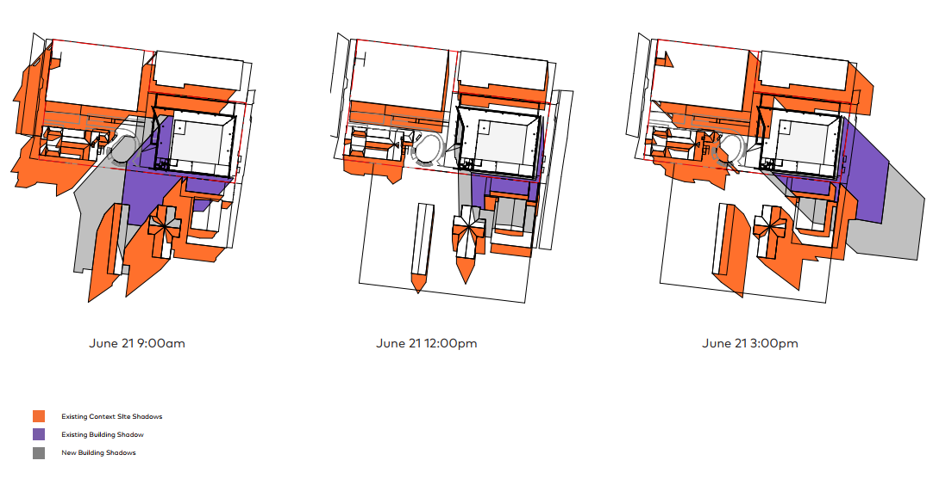
Figure 6: Shadow diagrams

Figure 6 depicts overshadowing of the proposed building (grey), and compares this to the existing building (purple). It is noted the increased overshadowing will be to the south, which contains a place of worship and associated hall and office. Despite the increased overshadowing, it is considered there will be negligible impact to these properties. All buildings turn their back to the north and are generally sited towards the southern side of the allotment ensuring increased overshadowing will primarily be to open areas (used for car parking), or the rear of buildings where there are roofs or minimal window treatments.

The other increased impact appears to the west. However, it is noted to the immediate east is Carrington Avenue with a car park associated with the rear of the Dubbo Regional Theatre beyond. Therefore again, impacts will be minimal.

Access and traffic – Council’s Infrastructure Strategy Branch reviewed the submitted Traffic Impact Statement and determined the surrounding road network to have sufficient capacity to cater for additional traffic movements generated by this development.

Public Domain – It is considered the proposed development will not have any detrimental impact on the public domain.

Utilities – As discussed, given the location of the site in the Central Business District there is ready access to all reticulated utility services. Council’s Infrastructure Strategy Branch has reviewed the development proposal and determined utility servicing in the locality should be adequate to serve this development, although a notation was still recommended that the Applicant liaise with Council’s Water and Sewerage Branch to confirm. An appropriate condition will be included on the consent that a larger water service connection be provided if needed.

Heritage – As discussed, the property is located adjacent to listed heritage items. Council’s Heritage Advisor has reviewed the Application and determined the development will not have an adverse impact on those items.

Other land resources – N/A

Water/air/soils impacts – It is considered that the development will not have an adverse impact on the local environment. There are no activities proposed which may cause adverse air, soil or water pollution. Appropriate conditions on the consent will ensure possible environmental impacts are minimised.

Flora and fauna impacts – With the exception of the two (2) street trees there will be minimal removal of any vegetation and as such negligible impact on the natural or built environment.

Natural environment – It is considered there will be no adverse impact on the natural environment.

Noise and vibration – Noise will be generated through construction through the use of power tools and the like. An appropriate condition will be included on the consent restricting work hours to minimise impacts to neighbouring property.

Noting the commercial locality, upon occupation the development is not likely to generate noise above that of neighbouring properties. No special conditions in relation to noise generation will therefore be included on the consent.

Natural hazards – Flooding matters have been discussed previously in this report.

Safety, security and crime prevention – As discussed previously in this report, access to the car parking areas will be restricted via roller shutters. These are setback 6 metres from the property boundary to ensure no conflict with road/pedestrian traffic, while gates are being opened or closed.

The design of the building ensures passive surveillance of the public domain to minimise risk of anti-social behaviour. Other security measures of note include restricted access to the basement carpark, and outdoor landscaped areas including the yarning circle being benefitted by passive surveillance as well as lighting for afterhours safety.

Social impact – It is considered there are only beneficial social impacts resulting from the proposed development.

Economic impact – It is considered there are only beneficial economic impacts resulting from the proposed development.

Site design and internal design – It is considered the development has been designed to integrate with the surrounding built form. It has also been designed to ensure functionality for users of the development.

Construction – Conditions on the consent will limit construction hours to mitigate noise impacts. A separate condition will also require a Construction Environment Management Plan to be submitted for approval prior to construction works commencing. The CEMP will, amongst other matters, require details on how noise impacts will be mitigated, and specifically request this address impacts on adjoining development including the radio studio.

Cumulative impacts – It is considered there will be no adverse cumulative impacts resulting from the proposed development.

Accordingly, it is considered that the proposal will not result in any significant adverse impacts in the locality as outlined above.

  - Section 4.15(1)(c) - Suitability of the site

Based on the conclusions within this report, it is considered the development to be suitable for the site and locality.

  - Section 4.15(1)(d) - Public Submissions

These submissions are considered in Section 4.3 of this report.

  - Section 4.15(1)(e) - Public interest

There are no matters other than those discussed in the assessment of the Development Application above, that would be considered contrary to the public interest.

- REFERRALS AND SUBMISSIONS

  - Agency Referrals

The development application has been referred to various agencies for comment/concurrence/referral as required by the EP&A Act and outlined below in Table 5.
There are no outstanding issues arising from these concurrence and referral requirements subject to the imposition of the recommended conditions of consent being imposed.

Table 5: Referrals to agencies
Referral/Consultation Agencies
Electricity supply authority | Section 2.48 – State Environmental Planning Policy (Transport and Infrastructure) 2021  Development near electrical infrastructure | The proposal is satisfactory subject to recommended conditions/requirements that will be included as a notation on the consent. | Y/N

  - Council Officer Referrals

The development application has been referred to various Council officers for technical review as outlined Table 6.

Table 6: Consideration of Council Referrals
Officer | Comments | Resolved
Engineering / Traffic | Following the receipt of further information, Council’s Senior Development Engineer (SDE) in the report dated 1 December 2022 (copy on file) and email dated 23 February 2023 did not raise any significant issues that require further investigation or that would prevent the Application from being granted consent with conditions. The conditions and notation recommended by the SDE will be included on the consent. | Yes  (conditions)
Building | Council’s Senior Building & Development Certifier (SBDC) in the report dated 26 September 2022 (copy on file) did not raise any significant issues that require further investigation or that would prevent the Application from being granted consent with conditions. The conditions and notations recommended by the SBDC will be included on the consent. | Yes  (conditions)
Health | Council’s Environment and Health Project Officer (EHPO) in the report dated 2 September 2022 (copy on file) did not raise any significant issues that require further investigation or that would prevent the Application from being granted consent with conditions. The conditions and notations recommended by the EHPO will be included on the consent. | Yes  (conditions)
Heritage | As discussed previously, Council’s Heritage Advisor in the report dated 17 August 2022 (copy on file) did not raise any significant issues that require further investigation or that would prevent the Application from being granted consent with conditions. | Yes

The outstanding issues raised by Council officers are considered in the Key Issues section of this report.

  - Community Consultation

The Development Application was placed on notification for a period ending 17 August 2022, during which time adjoining property owners were notified in writing of the proposed development.

Council received four (4) submissions during the notification period. The concerns raised are listed below with a planning comment attached:

- Impacts on neighbouring radio tower

Comment

The adjoining northern property is occupied by a local radio broadcaster, whose transmission tower is located on the roof of the building. Concerns were expressed by the operator that this higher building may impact on radio transmissions and receiving.

Based on development consents, it is noted the tower has a total height of 25.2 metres above ground level and is setback approximately 16 metres from the common property boundary (as per Development Consent D1996-108). The new building will have a height of 24.2 metres, therefore slightly below the tower height. Noting no evidence was provided by the objector demonstrating an adverse impact, based on the setback and building height not exceeding the height of the tower, no impact can be concluded.

- Boundary fence replacement and security issues

Comment

The submission raises concerns that a fence along the northern property boundary will be removed, and thus raises security concerns. Plans do not indicate fencing will be removed. An appropriate notation will be included on the consent that should any boundary fencing be required to be altered or replaced, it be undertaken in consultation with the relevant adjoining property owner in accordance with the requirements of the Dividing Fences Act 1991.

- Construction noise impacts

Comment:

The submission raises concern with construction noise impacts, noting a radio studio is located on adjoining property. A condition will require a Construction Environment Management Plan (CEMP) be submitted to Council for approval prior to construction works commencing. The CEMP will, amongst other matters, require details on how noise impacts will be mitigated, and specifically request this address impacts on adjoining development including the radio studio.

- Off-street car parking

Comment:

Council received three (3) separate submissions by persons likely to be employed within the new building who identify the development is not providing sufficient off-street parking to support the number of staff likely to be employed within the building. Concerns include:

There is the potential for up to 436 government work desks, however only 72 parking spaces, which will be mostly occupied by government (fleet) vehicles with:

- no allocation for staff parking;
- Staff have to rely on street parking which will cause increased pressure on parking availability for the general public in the area. Much of the surrounding area has timed parking restrictions; and
- Limited public transport options in Dubbo as an alternative, despite documentation stating this is a viable alternative to private travel to work.

As discussed within this report, the development provides compliant parking in accordance with the requirements of the Dubbo DCP 2013. Pursuant to Section 4.15(3A) of the Environmental Planning and Assessment Act 1979, if a Development Control Plan sets a standard, and the development complies with that standard, the consent authority cannot require a more onerous standard. In this regard, despite what would appear to be a parking shortfall from a practical standard, compliance with the DCP is achieved.

Noting the practical concerns raised by objectors, Council requested the Applicant elaborate the parking provision. The following information was supplied:

- “Property and Development NSW will provide a centralised fleet parking facility at the NSW Government owned site at 209 Cobra Street. This strategy will redirect most of the fleet vehicle requirements out of the Dubbo CBD and will maximise the use of the basement parking facilities at the Hub for staff members.
- The Hub building will provide shared, bookable parking facilities for staff within the basement over two levels.
- The Hub Operations Management Plan will provide parking options for staff working late or during darker winter months to be able to park their vehicle in a safe environment without walking through the streets at night.
- It is anticipated that workplace participation will align with standard Government workplace attendance with a large number of staff opting to ‘work from home’ on given days throughout the week. Desk time (and corresponding parking need) has also been considered in line with staff travel practices outside of Dubbo for work purposes.
- Project supporting active transport options (providing EOT facilities and bicycle parking).”

The above is noted.

- KEY ISSUES

The following key issues are relevant to the assessment of this application having considered the relevant planning controls and the proposal in detail:

  - Traffic Impact Statement

Following a request for further information an addendum to the submitted Traffic Impact Statement was provided that addressed Council’s initial concerns with regards to:

- The initial Statement only considered staff traffic generation, and did not consider visitor traffic generation;
- A lack of traffic analysis of the Church Street / Carrington Avenue intersection with respect to visitor vehicle movements;
- A lack of traffic analysis for the intersection of Talbragar Street and Carrington Avenue (staff and visitor traffic generation); and
- The Traffic Impact Statement to undertake analysis of the total number of people working at the current building, and the future total number of people using the proposed building.

The above matters were satisfactorily addressed in the submitted addendum to the Traffic Impact Statement.

5.2 Delivery Area

Concerns were initially raised with regards to the location of the delivery area at the front of the building adjacent to the Carrington Avenue footpath. Concerns were raised from an amenity perspective, as well as pedestrian safety. The Applicant subsequently amended plans to remove this component, with a dedicated loading zone to be provided on the street adjacent to the property, along with a small loading dock within the carparking area.

5.3 Waste Collection

Concerns were raised that waste collection vehicles would not be able to access the loading dock and bin storage area behind the building line. The Applicant subsequently advised that waste would be collected kerbside. No objections raised.

5.4 Radio Tower Impacts

As discussed, a submission was received from the adjoining northern property owner, whose transmission tower is located on the roof of the building. Concerns were expressed by the operator that this higher building may impact on radio transmissions and receiving. Based on development consents, it is noted the tower has a total height of 25.2 metres above ground level and is setback approximately 16 metres from the common property boundary (as per Development Consent D1996-108). The new building will have a height of 24.2 metres, therefore slightly below the tower height. Noting no evidence was provided by the objector demonstrating an adverse impact, based on the setback and building height not exceeding the height of the tower, no impact can be concluded.

5.5 Parking

A number of objections were received that identified there would be a lack of parking spaces available for the development. As identified within this report, the parking provision is compliant with the Dubbo DCP 2013. Further, the Applicant has identified operational arrangements that will assist in ensuring a suitable parking provision (refer Section 4.3 of this report).

- CONCLUSION

This development application has been considered in accordance with the requirements of the EP&A Act and the Regulations as outlined in this report. Following a thorough assessment of the relevant planning controls, issues raised in submissions and the key issues identified in this report, it is considered that the application can be supported.

The proposed development is not considered likely to have any significant negative impacts upon the environment or upon the amenity of the locality.

The proposed development is consistent with the objectives of the applicable Environmental Planning Instruments, Development Control Plan 2013 and Council policies and is therefore recommended for approval subject to the conditions of consent attached.

Approvals under the Local Government Act, 1993 integrated with the Consent: Nil

Building Code of Australia Classification

Applicable Building | Whole or Part | Class
Seven (7) storey office building incorporating 2 underground basement carpark levels | Part – Basement Level 2  Part – Basement Level 1  Part – Ground Floor  Part – Level 1  Part – Level 2  Part – Level 3  Part – Level 4 | 7a  7a  5  5  5  5  5

- RECOMMENDATION

That the Development Application D22-356 for Public Administration Building and consolidation/boundary adjustment at Lots 21 & 22 DP 565246 & Lot 100 DP 1098632, Lot 3 DP 1128529 Res 24309, Lot 4 DP 1128529, No’s 37-39 Carrington Avenue & No’s 130-142 Brisbane Street, Dubbo be APPROVED pursuant to Section 4.16(1)(a) or (b) of the Environmental Planning and Assessment Act 1979 subject to the draft conditions of consent attached to this report at Attachment A.

The following attachments are provided:

- Attachment A: Draft Conditions of consent
- Attachment B: Approval from the Crown (applicant) for imposition of Conditions
- Attachment C: Architectural Plans

